**USER INTEFACE AND DESIGN**

**NAME SANDHIYA P ROLL NO 230701282**

# Exercise 10 Create a data visualization (e.g., pie charts, bar graphs) for an inventory management system using javascript

# Objective

To develop an interactive web page that visualizes inventory data using JavaScript and Chart.js, displaying both pie and bar charts.

# Tools Required

• Visual Studio Code (VS Code)

• Live Server Extension

• Chart.js JavaScript Library

## Set Up the Project Folder

Create a folder named InventoryVisualization and open it in VS Code.

## Create index.html

Create a new file named index.html and paste the HTML content into it.

## Create script.js

Create another file named script.js and paste the JavaScript content into it.

## Install Live Server Extension

Install the Live Server extension in VS Code to preview the webpage in real-time.

## Preview the Web Page

Right-click index.html and choose 'Open with Live Server' to see the visualizations.

## HTML Code (index.html)

<!DOCTYPE html>  
<html lang="en">  
<head>  
 <meta charset="UTF-8">  
 <title>Inventory Management Visualization</title>  
 <style>  
 body {  
 font-family: Arial, sans-serif;  
 text-align: center;  
 margin: 50px;  
 }  
 canvas {  
 margin: 20px auto;  
 }  
 </style>  
</head>  
<body>  
 <h1>Inventory Management System</h1>  
 <canvas id="pieChart" width="400" height="400"></canvas>  
 <canvas id="barChart" width="400" height="400"></canvas>  
 <script src="https://cdn.jsdelivr.net/npm/chart.js"></script>  
 <script src="script.js"></script>  
</body>  
</html>

## JavaScript Code (script.js)

const inventoryData = {  
 labels: ['Electronics', 'Clothing', 'Home Appliances', 'Books', 'Toys'],  
 datasets: [{  
 label: 'Items in Stock',  
 data: [200, 150, 100, 80, 50],  
 backgroundColor: ['#FF6384', '#36A2EB', '#FFCE56', '#4BC0C0', '#9966FF'],  
 }]  
};  
  
const ctxPie = document.getElementById('pieChart').getContext('2d');  
new Chart(ctxPie, {  
 type: 'pie',  
 data: inventoryData,  
 options: {  
 responsive: true,  
 plugins: {  
 title: {  
 display: true,  
 text: 'Inventory Distribution'  
 }  
 }  
 }  
});  
  
const ctxBar = document.getElementById('barChart').getContext('2d');  
new Chart(ctxBar, {  
 type: 'bar',  
 data: inventoryData,  
 options: {  
 responsive: true,  
 plugins: {  
 title: {  
 display: true,  
 text: 'Items in Stock by Category'  
 }  
 },  
 scales: {  
 y: {  
 beginAtZero: true  
 }  
 }  
 }  
});

OUTPUT

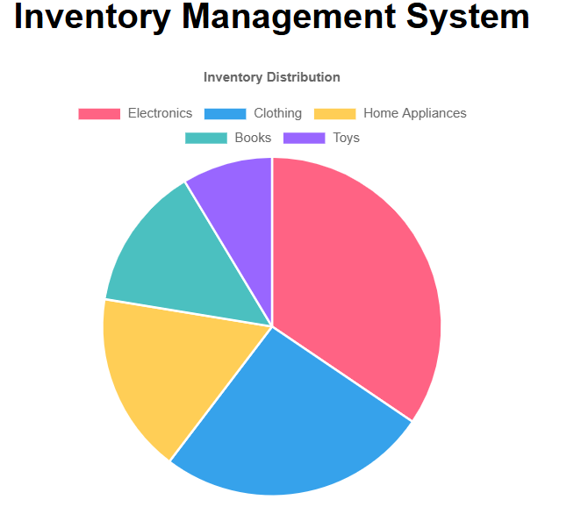

# 

# Summary

This project uses HTML, JavaScript, and Chart.js to visualize inventory data. Live Server allows for real-time preview. The pie chart represents category distribution, and the bar chart shows stock quantity per category.